**Ex 3 Text Processing in PERL**

**Objective:**

To create a server side PERL script to retrieve dynamic information from a website and display it. Use MySQL as database to store the retrieved information

**Installation Procedure:**

1. To Install MySQL

sudo apt-get install mysql-server mysql-client

1. Install Apache’s PERL module

sudo apt-get install libapache2-mod-perl2

1. Configuring Apache to execute cgi-scripts such as PERL

sudo mkdir /var/www/cgi-bin

Add the following line in /etc/apache2/site-available/default

<Directory /var/www/cgi-bin >

Options ExecCGI

AddHandler cgi-script cgi pl

</Directory>

1. To install necessary PERL packages to process html files

sudo apt-get install libwww-perl

sudo apt-get install libhtml-treebuilder-xpath-perl

**Aim:**

Using the setup done for PERL

1. Monitor changes in the stock market using live updates from http://money.rediff.com
2. Using the obtained information from the site, dynamically update a HTML page with the details
3. Provide storage of values in database in regular intervals.

**Procedure:**

1. To connect PERL with MySQL include

use DBD::mysql

1. Include the package LWP::Simple to get the contents from the specified URL
2. Use the tree builder package to parse the retrieved html code and build a html tree capable of being manipulated through PERL script
3. Use the method look_down to extract the necessary elements from the HTML tree of the URL
4. Use prepare, finish and execute methods of DB to update the database with the parsed details.

**Program Code:**

#!/usr/bin/perl -w

use strict;

use warnings;

use LWP::Simple;

use HTML::Tree;

use DBI;

use DBD::mysql;

#Connectin to Database

my $host="";

my $database="stock";

my $user="root";

my $pw="ssn";

my $connect = DBI->connect("DBI:mysql:$database:$host",$user,$pw);

my $myquery = "";

my $url_full = "http://money.rediff.com";

my $content = get($url_full);

if($content)

{

my $tree = HTML::Tree->new();

$tree->parse($content);

my $bse_div = $tree->look_down( _tag => 'div', 'id' => 'sensTab1' );

my $nse_div = $tree->look_down( _tag => 'div', 'id' => 'sensTab2' );

if($bse_div)

{

print "\nBse index: ";

my $bse_val = $bse_div->look_down( _tag => 'span' )->as_text;

print $bse_val;

print "\nToday's change: ";

my $bse_today = $bse_div->look_down( _tag => 'span', 'class' => 'red');

if($bse_today) { }

else

{

$bse_today = $bse_div->look_down( _tag => 'span', 'class' => 'green');

}

print $bse_today->as_text;

print "\nBse percent: ";

#my @temp = $bse_div->content_list;

my $temp = substr $bse_div->as_text, -7, -1;

print $temp;

my $bse_text = $bse_today->as_text;

$myquery="INSERT INTO stock_details(market,price,daily_change,percentage_change) VALUES ('BSE',?,?,?)";

my $statement = $connect->prepare($myquery);

$statement->execute($bse_val,$bse_text,$temp);

}

else

{

print "Not found";

}

if($nse_div)

{

print "\nNse index: ";

my $nse_val = $nse_div->look_down( _tag => 'span' )->as_text;;

print $nse_val;

print "\nToday's change: ";

my $nse_today = $nse_div->look_down( _tag => 'span', 'class' => 'red');

if($nse_today) { }

else

{

$nse_today = $nse_div->look_down( _tag => 'span', 'class' => 'green');

}

print $nse_today->as_text;

print "\nNse percent: ";

my $temp = substr $nse_div->as_text, -7, -1;

print $temp;

my $nse_text = $nse_today->as_text;

$myquery="INSERT INTO stock_details(market,price,daily_change,percentage_change) VALUES ('NSE',?,?,?)";

my $statement = $connect->prepare($myquery);

$statement->execute($nse_val,$nse_text,$temp);

}

else

{

print "Not found";

}

}

else

{

print "Content is empty"

}

print "\n";

**Screenshots:**

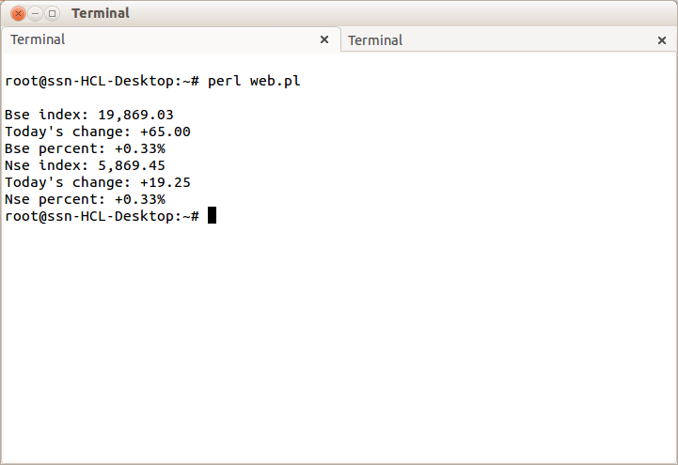

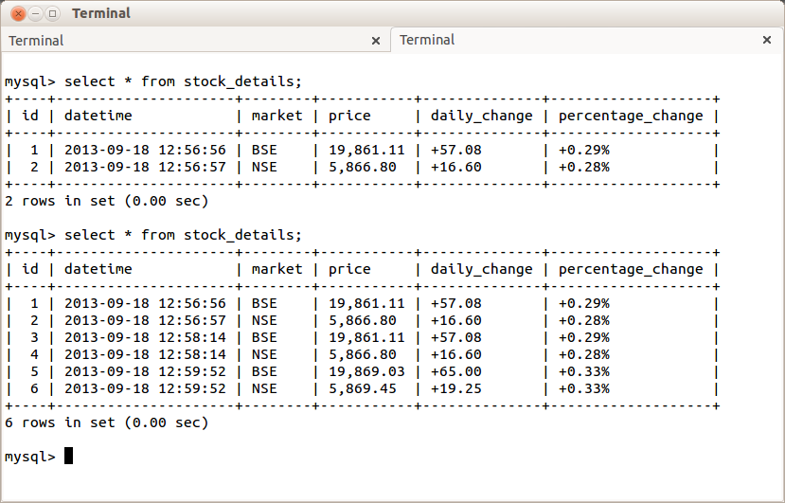

**Result:**

Thus the Apache server has been modified to accept and run PERL scripts. Perl script was written to retrieve data from http://money.rediff.com and provide regular updates on BSE and NSE stock values using LWP::Simple. Text processing was done using the HTML::Tree package. The data was also updated into a relational schema in MySQL database using DBD::mysql.